Ronnie Corpuz
CS 499 Milestone Three: Enhancement Two
Algorithms and Data Structures
Artifact: Contact Service (CS320)
Dr. Sherri Maciosek, Ph.D.
5/24/2026

Artifact Selection Description
The artifact I selected for Enhancement Two is the Contact Service project from CS 320 Software Testing, Automation, and Quality Assurance. It was originally developed during my CS 320 coursework before being enhanced for my CS 499 ePortfolio. The purpose of the project was to create a contact management system that can store, update, delete, and retrieve contact records.
The project includes the Contact class, ContactService class, and JUnit test files. The Contact class stores contact details such as contact ID, first name, last name, phone number, and address. The ContactService class manages contact records using an existing HashMap structure. The JUnit tests confirm that contacts are created correctly and that the ContactService methods function as expected.
Why I Included the Artifact
I chose this artifact because it demonstrates my ability to work with data structures, validation, unit testing, and defensive programming. It fits the Algorithms and Data Structures category because ContactService already uses a HashMap to store each contact with its unique contact ID. This allows the program to quickly find, update, and delete contact records.
This artifact also shows that data structures need to be protected with proper validation and error handling. While a HashMap provides efficient access to records, the service still needs to handle invalid input, duplicate keys, missing keys, and null values safely. For this enhancement, I focused on improving how the service interacts with the existing HashMap instead of changing the overall design.
The original project already supported adding, deleting, updating, and retrieving contacts. I improved it by adding stronger defensive programming and input validation. I added validation for null contacts and null or blank contact IDs before HashMap operations. This helps prevent ambiguous errors and provides the user or developer with a clear exception message when invalid input is entered.
I also added two helper methods: contactExists() and getContactCount(). The contactExists() method checks whether a contact ID exists in the HashMap. The getContactCount() method returns the total number of contacts currently stored in the service. These methods make the service more useful and easier to test without changing the project's main structure.
The JUnit tests were also improved. Before the enhancement, ContactServiceTest had 6 tests. After the enhancement, it had 13 tests. The added tests validate null contact handling, blank contact ID handling, null contact ID handling, partial updates, contact existence checks, and contact count updates after adding or deleting records. After completing the enhancement, ContactServiceTest passed 13 out of 13 tests, and ContactTest still passed 10 out of 10 tests.

Computer Science Program Outcomes
This enhancement supports several Computer Science program outcomes. The main outcome addressed is the ability to design and evaluate computing solutions using algorithmic principles and computer science practices. The Contact Service project uses a HashMap to manage contact records efficiently, and the enhancement improved the reliability of operations that interact with it.
This enhancement also supports the use of well-founded techniques, skills, and tools in computing practices. I used Java, Eclipse, JUnit 5, object-oriented programming, and unit testing to enhance the artifact. These are practical tools and techniques used in software development.
This enhancement also supports the security mindset outcome. Although this is not a security application, defensive programming improves software safety. By validating input before HashMap operations, the service handles unexpected input more safely and reduces avoidable runtime errors.
I do not need to modify my original outcome coverage plan at this time. Enhancement One focused on software design and engineering using the Travlr Getaways project. Enhancement Two focuses on Algorithms and Data Structures using the Contact Service project. Enhancement Three will focus on databases using the Grazioso Salvare Dashboard project.

Reflections on Enhancement Experience
Enhancing this artifact helped me see how small improvements can make a program more reliable. The original Contact Service already worked and passed its tests, so I wanted to avoid large changes that could break the project. My goal was to improve code quality while keeping the original architecture intact.
One important lesson I learned was that working code does not always mean fully protected code. The original service worked with valid input, but it did not fully protect against null contacts or blank contact IDs. By adding validation before HashMap operations, I made the service more stable and easier to troubleshoot.
I also learned the value of testing before and after modifications. Before making changes, I confirmed that ContactServiceTest passed 6 out of 6 tests and ContactTest passed 10 out of 10 tests. After the enhancement, ContactServiceTest passed 13 out of 13 tests, and ContactTest still passed 10 out of 10 tests. This gave me confidence that the enhancement improved the artifact without breaking existing functionality.
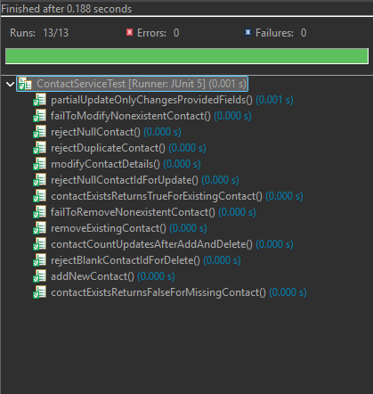
Figure 1
ContactServiceTest results after Enhancement Two, showing 13 out of 13 tests passed with 0 errors and 0 failures.

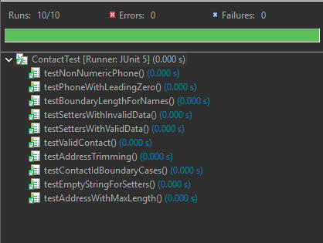
Figure 2
ContactTest results after Enhancement Two, showing 10 out of 10 tests passed with 0 errors and 0 failures.
One challenge I faced was setting up the project in Eclipse. Since it had been a while since I worked with this project, I had to re-establish the source folder configuration and reconnect JUnit 5 to the build path. Once those setup issues were fixed, I was able to run both test suites and complete the enhancement.
This project also helped me connect data structures to software quality. The HashMap is important because it stores contacts by unique contact ID, enabling efficient retrieval. Protecting the HashMap with validation and exception handling is also important because efficient access alone does not make the program reliable. This showed me how algorithms, data structures, testing, and defensive programming work together to create a better software product.

AI Usage Acknowledgment
I used ChatGPT to help review the rubric, organize my enhancement plan, troubleshoot Eclipse setup steps, and improve the wording of this narrative. I reviewed and tested the code changes in Eclipse and verified that the enhanced Contact Service passed all JUnit tests.

